 | Fri 24/11/22 | A digital copy of this is on the laptop.
Time | SUBJECT | Explanation | Resources
8.30am | Friday Friendly | Students know what to do,  On arrival, students will find the Friday Friendly box and write a special note to somebody else in the class…  There are no popsticks for this anymore so students choose who they would like to write to.  They will need to write something kind about the person they choose and post it in the box. | Friday Friendly Sheets  (On desk near the door)
8:45am | ASSEMBLY SET UP | Before the siren ALL chairs need to go to the undercover area to be set up. Students know where our chairs should go.  (Back right-hand side if you are looking at the stage).
8:50am | SIREN & ASSEMBLY | Siren sounds, students to head to the undercover area, there will be more chairs than students as we have several kids playing violin and viola, they will join the class when they have finished.
9.30am | Spelling Assessment | Complete assessment 100 in the Spelling Mastery Book.  Let students know that if it is not complete, they will miss their “Quick Fit” time finishing it.  Students to use their spelling mastery books to input their scores | Assessment Sheets
9.50am | QF | If time before sport, let the kids have a run!  Hats on!
10am | SPORT | Courtney Jones will arrive at 10am for Sport.  Check with admin for where you need to be.
BREAK 1  11am | DUTY! | NO DUTY
11:40am | MINDFULNESS | Students to take 5 minutes to reset after Break 1. | Spotify Playlist
11.45am | HaSS | Students to continue with their Asia records.  Reminder, they need to research and find a record for every country in Asia…this will be their last research lesson.  Students know when to do here.  Hand out the sheets and watch them go! | Asia Documents
12:40pm | Graduation Practice | Graduation Practice.  Work with Marc (Room 18) on this.  Students should be practicing their speeches and graduation preparation.
BREAK 2 |  | You are on DUTY in the nature playground and junior playgrounds.  AREA 3
14.00pm | Health | An introduction to body changes during puberty.  We will be reading about changes that happen to our bodies during puberty sessions in the following weeks, to introduce this topic, there are a couple of paragraphs that are some introduction ideas.  Students will take time to read the paragraphs and then answer a quiz.  All of this is on.  www.mrtoddsclassroom.com  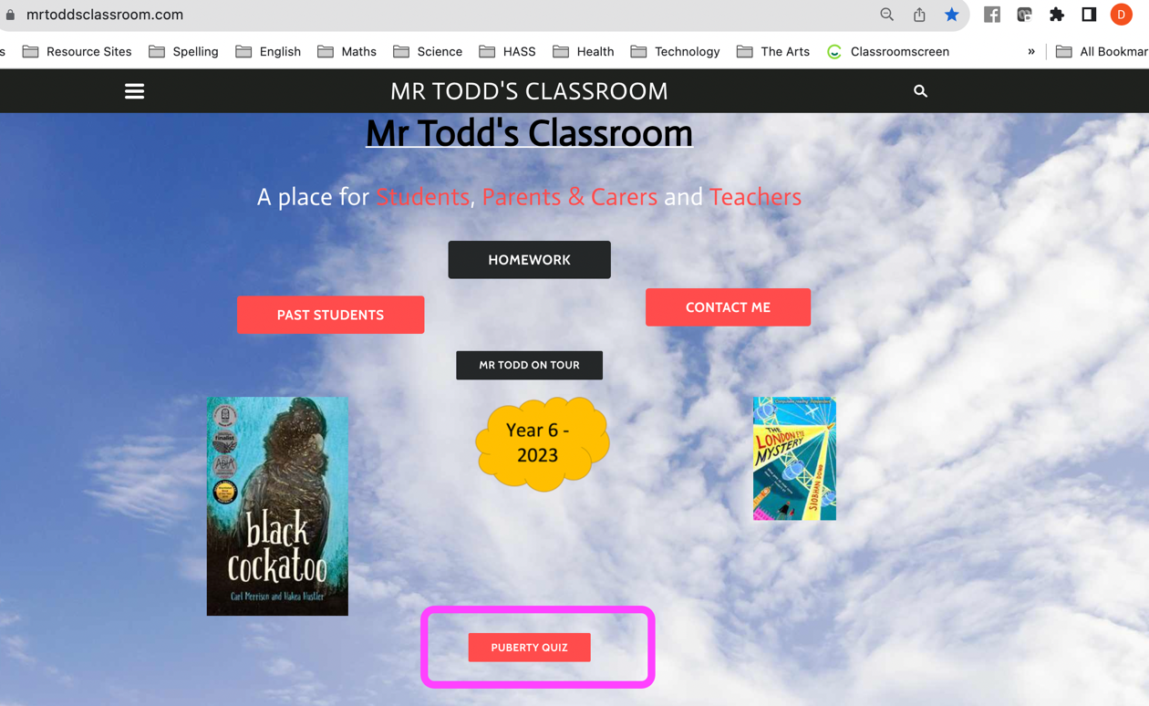  Once they have finished, they can complete the wordsearch on ‘personal hygeine’ | iPads  Wordsearch

