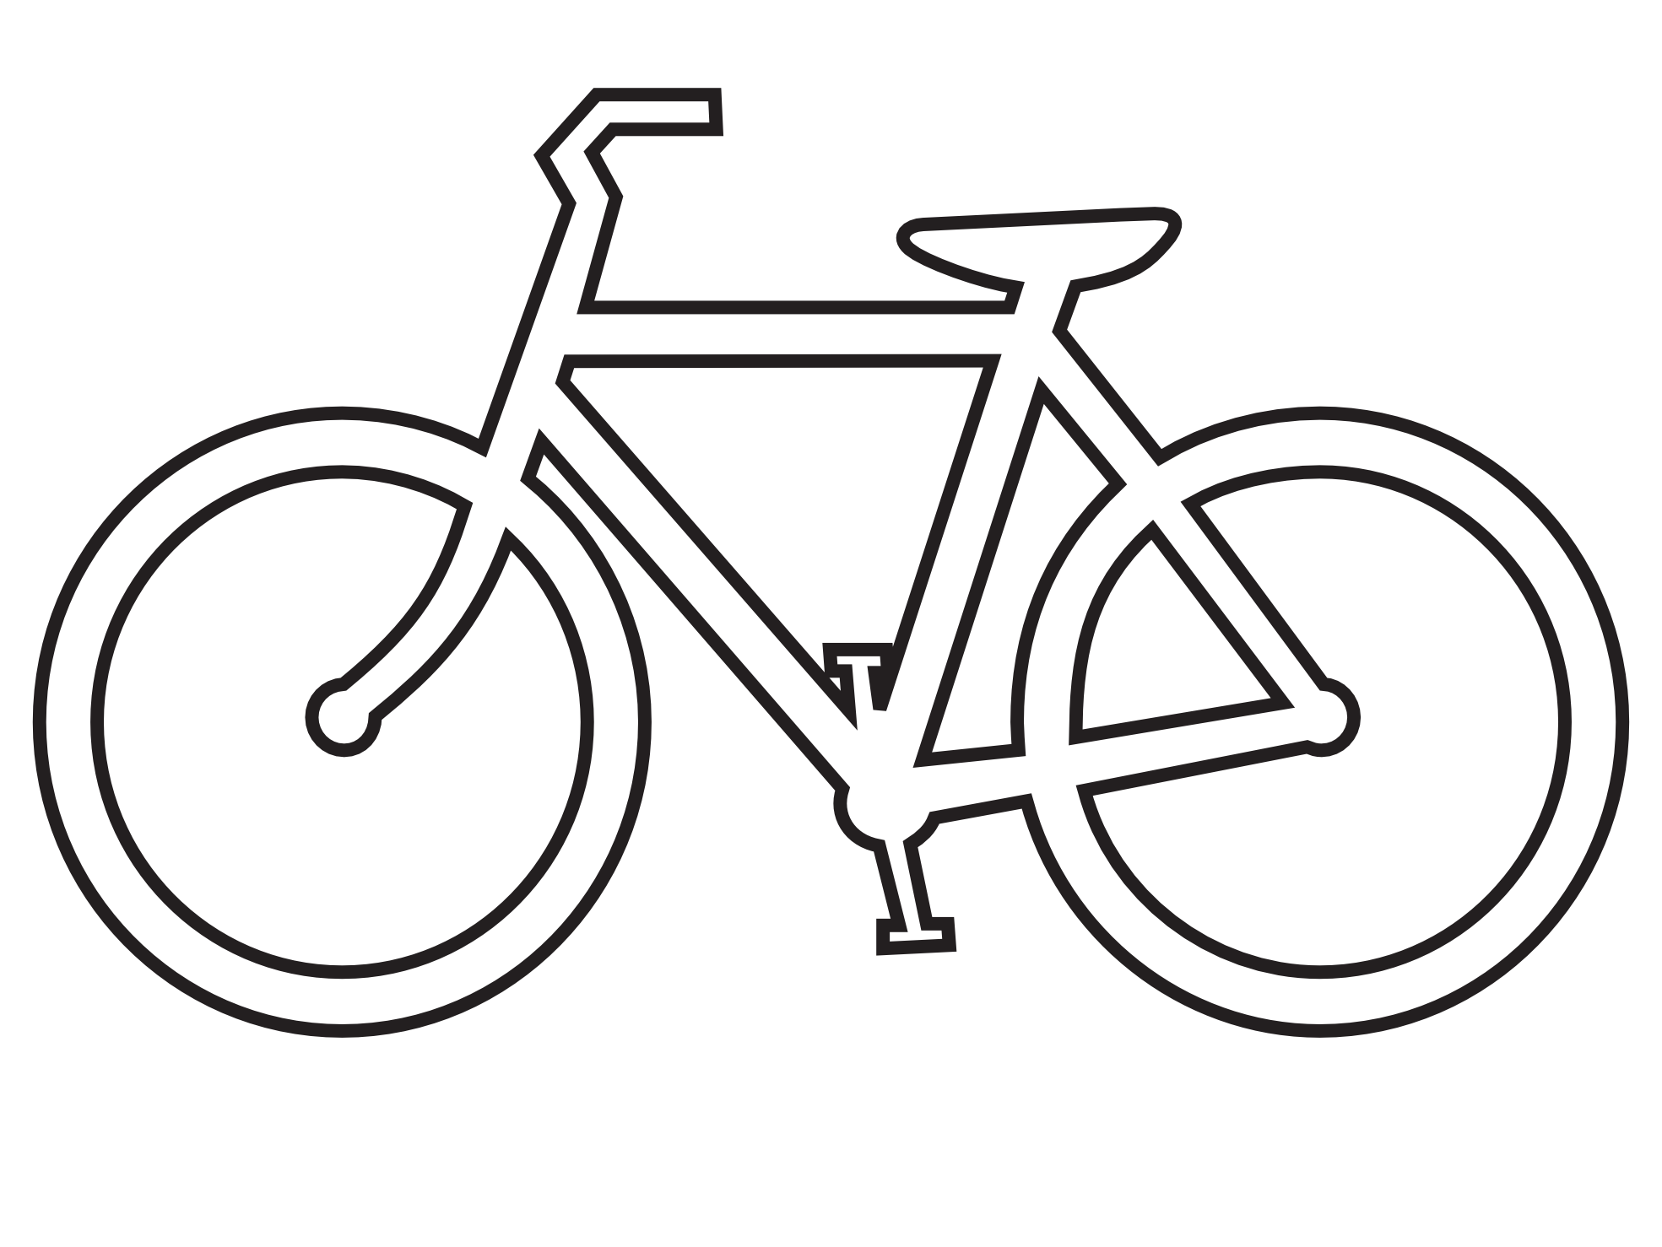

Decorate your own bike competition – Just like they did in South Australia